Homework PACKET 9

iDAHO pUBLIC dRIVER eDUCATION

RURAL DRIVING

RURAL (COUNTRY) DRIVING
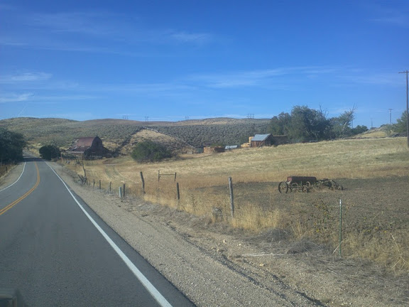Driving on this quiet country road might seem safer than more crowded roads in the city because there is less traffic, fewer signs, almost no pedestrians, and fewer intersections.

However, nearly twice as many fatal crashes occur on rural roads compared to urban roads.

Road surfaces in rural areas can vary greatly. Some roads are paved while others are dirt or loose gravel. Shoulders, if there are any, might be narrow. At night, without street lights, it may be very difficult to see where the road is going and corners can easily be missed; resulting in a harmful – even fatal- crash.

And while road conditions are often worse and unpredictable out in the country, speed limits are usually higher! This is where it is important to remember Idaho’s “Basic Rule” when it comes to speed: you can only drive the speed limit if conditions are ideal. On rural roads, especially at night or in bad weather, conditions will not be ideal and will require a speed under the posted limit.

RURAL INTERSECTIONS

We know city intersections can get complicated and busy – but speeds are typically slow and navigating them safely just takes a little patience. Rural intersections are completely different.

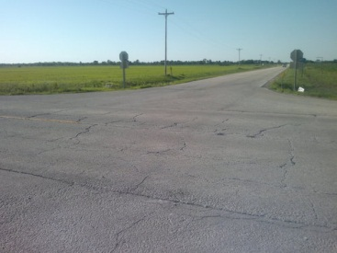

At higher speeds on rural roads a driver can easily miss a stop sign and end up causing a serious injury or fatal crash.

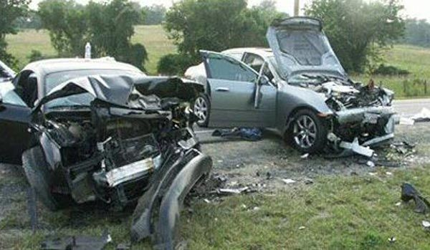

Using IPDE is very important out on rural roads because you have less time to IDENTIFY and respond to a situation or hazard. If you are not constantly looking ahead you may have to make an emergency maneuver to avoid something that suddenly appears in your path of travel. Last second responses at higher speeds can result in loss of control and a crash.

HOMEWORK PACKET 9

Idaho public driver education

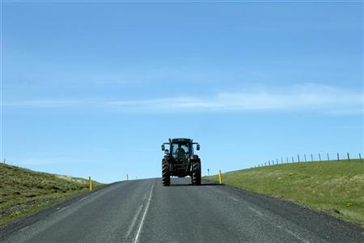

SLOW MOVING VEHICLES

If you are traveling at 55mph and come upon this tractor, what should you do?

First, slow down! The tractor is likely traveling at 25mph or less and you need to keep a minimum 3-second following distance. Second, analyze the possibility of passing the tractor. Is this a safe location to pass?

The answer is no. The roadway markings make this an unlawful location to pass and the crest of the hill makes it difficult to see oncoming traffic that is likely traveling 55mph or more. Continue to follow the tractor at a safe (3-second) distance until you go over the hill and then look for a safe and legal place to pass. The tractor may even pull off the road by then.

ANIMALS

Animals live in rural areas and many of our rural roads pass through their habitat. Unless there are barriers to prevent animals from crossing these roads, conflicts and collisions will occur. Hitting a large animal, a cow, elk, or moose for example, can result in the complete destruction of the vehicle and the death of those in the car and the animal.

In areas where large animals are common, reduce your speed and stay alert.

VISUAL SEARCH PATTERN

The orderly visual search pattern we covered previously must be used in rural driving conditions just as much (or more) as other conditions.

Constantly search in the 12-15 second range ahead of you. Look for clues of hazards that might change an open zone to a closed one. 12-15 seconds ahead of you at higher rural speeds will be much further down the road when compared to 12-15 seconds ahead on an urban road. Why?

TWO-LANE ROADS

Most rural roads are two-lanes wide and can be curvy, steep, and unpredictable. Unlike freeway lanes, rural highway lanes are not separated by a median or barrier. Opposing traffic, each traveling at speed at 55mph or higher, can come within five feet of one another as they pass. It only takes one of those drivers to be distracted for a split second to cause one car to cross the center line and hit the other car.

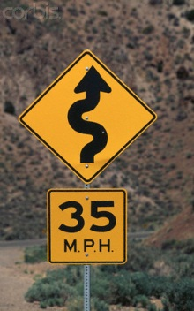

When approaching a curve on a rural highway you may see a yellow speed sign. These are not displaying the legal speed limit but the recommended speed limit for that particular corner. Engineers have carefully designed and tested each corner and posted these safe recommended speeds. You will find that staying as close to these speeds as possible will create a smooth and comfortable corner for you and your passengers.
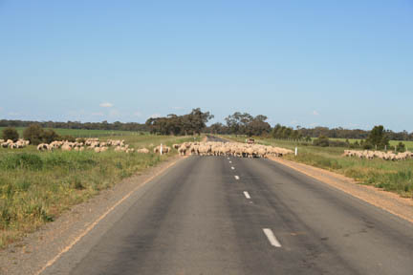

Can you see what is blocking this two-lane rural road ahead? Believe it or not, this is a common sight in Idaho: a sheep herd is being moved from one grazing field to another and the paved road is the best way for the sheepherders to do it. If you were cruising down this road at 55 or 60mph and weren’t looking ahead or expecting any hazards, what could happen?

MOUNTAIN DRIVING

Mountain driving is common in Idaho so Idaho drivers must understand their unique challenges. The weight of your vehicle and gravity will work against you when going both up and downhill. It is illegal in Idaho to coast down hills in neutral – and will cause your vehicle to speed up and you may lose control. If you are braking often when going
downhill you should shift to a lower gear.

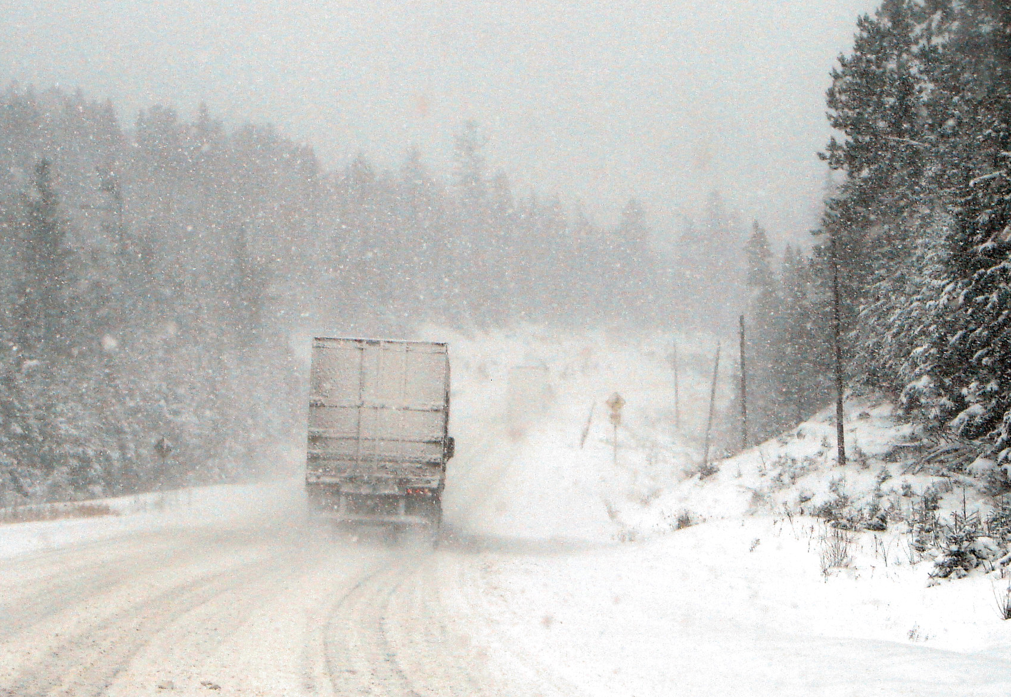

Mountain weather can create very hazardous driving conditions, including fog, snow, and ice. Conditions can change quickly and shaded areas of the road can stay snow or ice-covered even when sunny spots are dry.
HOMEWORK PACKET 9

Idaho Public Driver Education
The high altitudes of some mountain roads can affect both the driver and the vehicle. High altitudes have lower amounts of oxygen and can cause shortness of breath, increased heartbeat, headache, reduced concentration, and drowsiness. The highest paved road in America is in Colorado and is over 14,000 feet in elevation!

DESERT DRIVING

Desert driving has its own unique challenges, including intense daytime heat that can cause vehicle malfunctions, routine landscapes that can get boring, and glare from the sun that can be blinding.

Before driving in hot desert-like conditions, make sure your vehicle is prepared. Radiator fluids should be checked when the engine is cool and kept full. Tire pressure should be checked regularly and kept above the recommended PSI. A tire with low air pressure builds up heat and can result in tire failure. But a tire with too much air pressure can expand so much that it causes a tire failure as well.

Rural roadways in Idaho vary from straight flat desert highways to high, curvy, snow-covered mountain passes. Driving here requires you to be prepared and adjust to the ever-changing conditions.

REVIEW QUESTIONS
HOMEWORK PACKET 9

NAME: _______________________________________ DATE: ____________

DIRECTIONS: Answer the following questions based on what you learned from the homework packet.

1. While more crashes occur in the city, more fatal crashes occur in the country. Why?

2. Last second responses to hazards on rural roads can result in:

3. What is the difference between looking 12-15 seconds ahead in the city and 12-15 seconds ahead in the country?

4. What is the difference between white and yellow speed signs?

5. Name three possible hazards of a rural mountain road:
a.
b.
c.

6. Name three possible hazards of a rural desert road:
a.
b.
c.

7. Name three things that may surprise you when coming around a blind corner in a rural environment:
a.
b.
c.

